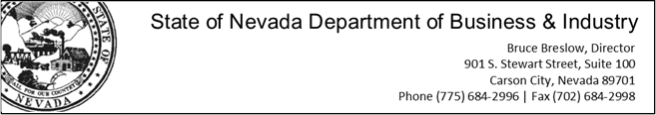

**For Immediate Release: September 22, 2014**

Contact: Teri Williams, [twilliams@business.nv.gov](mailto:twilliams@business.nv.gov); (702)486-0407

**Nevada Housing Division launches new homebuyer grant program**

*Home is Possible program to provide grants to cover down-payment, closing costs for eligible borrowers*

**Carson City, NV**– The Nevada Housing Division (NHD) today launched *Home is Possible*, a new home buyer program that provides qualified homeowners in Clark and Washoe counties a grant of up to 4% of the loan amount to be applied toward down payment and/or closing costs. The program will be available to homebuyers financing a primary residence with a government insured FHA, USDA RD or VA mortgage beginning September 22. Grants for borrowers seeking conventional financing will be available in November.

*Home is Possible* General Requirements:

* Homebuyer must purchase the home to occupy as the primary residence
* Minimum credit score of 640 for government insured loans; 660 for manufactured homes and 680 for conventional loans
* Home purchase price under $400,000
* Qualifying income on mortgage application must be below $95,500
* Borrowers must take an approved home buyer education course
* Borrower must meet the lender’s specific underwriting requirements
* There is no repayment obligation; no first-time home buyer requirement

“This is a unique down payment assistance program in that borrowers are not required to be first-time home buyers and a higher income limit means more people can qualify,” said Housing Division Administrator CJ Manthe.

The program, funded from private taxable mortgage funds, will be available on an ongoing basis. To get started, interested home buyers should visit <http://housing.nv.gov> to find a list of participating lenders.

**About the Nevada Housing Division**

The Nevada Housing Division was created by the Nevada Legislature in 1975, when it was recognized that a shortage of safe, decent, and sanitary housing existed throughout the State for low- and moderate-income Nevadans. Their mission is to improve quality of life by providing affordable housing opportunities. For more information visit [www.housing.nv.gov](http://www.housing.nv.gov).

**###**