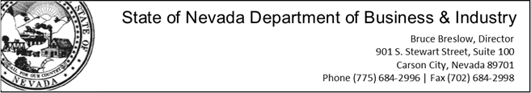

Contact: Teri Williams, Public Information Officer

Email: [twilliams@business.nv.gov](mailto:twilliams@business.nv.gov); Phone: 702-486-0407

**For Immediate Release: July 11, 2014**

**Nevada Housing Division awards $4.5 million in weatherization grants to provide free energy efficiency services to low-income residents**

**Carson City, NV**--The Nevada Housing Division (NHD) recently announced the allocation of statewide grants to six sub-grantees to perform energy efficiency assessments and weatherization services at no cost to low-income residents. The program offers families, particularly those with elderly occupants and children, with safety and cost-saving measures such as installation of solar screens and insulation, HVAC repairs, and carbon monoxide detectors. The program also provides emergency replacement of failed heating and cooling equipment at no cost to owner-occupied dwellings.

The program has provided weatherization assistance to over 25,000 households since inception. Current grant funds will provide services to approximately 850 households during the next fiscal year.  The Division estimates that approximately 150,000 Nevada households could qualify for services and encourages those that are interested to visit the website to determine if they qualify.

“Residents that have weatherization services performed in their home can benefit from monthly cost savings that can be upward of $50 a month, which can put around $600 back in their pocket at the end of the year,” said Sue Martin, NHD weatherization program manager. “This assistance program truly provides a positive long-term, sustainable impact on a household’s budget.”

Funding for the grants allocated by the Division comes from the Department of Energy, Department of Health and Human Services, State of Nevada utility funds and Southwest Gas.

To learn more about the Weatherization Assistance Program or to determine eligibility for services, please visit <http://housing.nv.gov/programs/Weatherization>.