BRIAN SANDOVAL
Governor
RICHARD WHITLEY, MS
Director
DEPARTMENT OF HEALTH AND HUMAN SERVICES
AGING AND DISABILITY SERVICES DIVISION
3416 G oni Road, Suite D132
Carson City, NV 89706
Telephone (775) 687-4210 • Fax (775) 687-0576
http://adsd.nv.gov
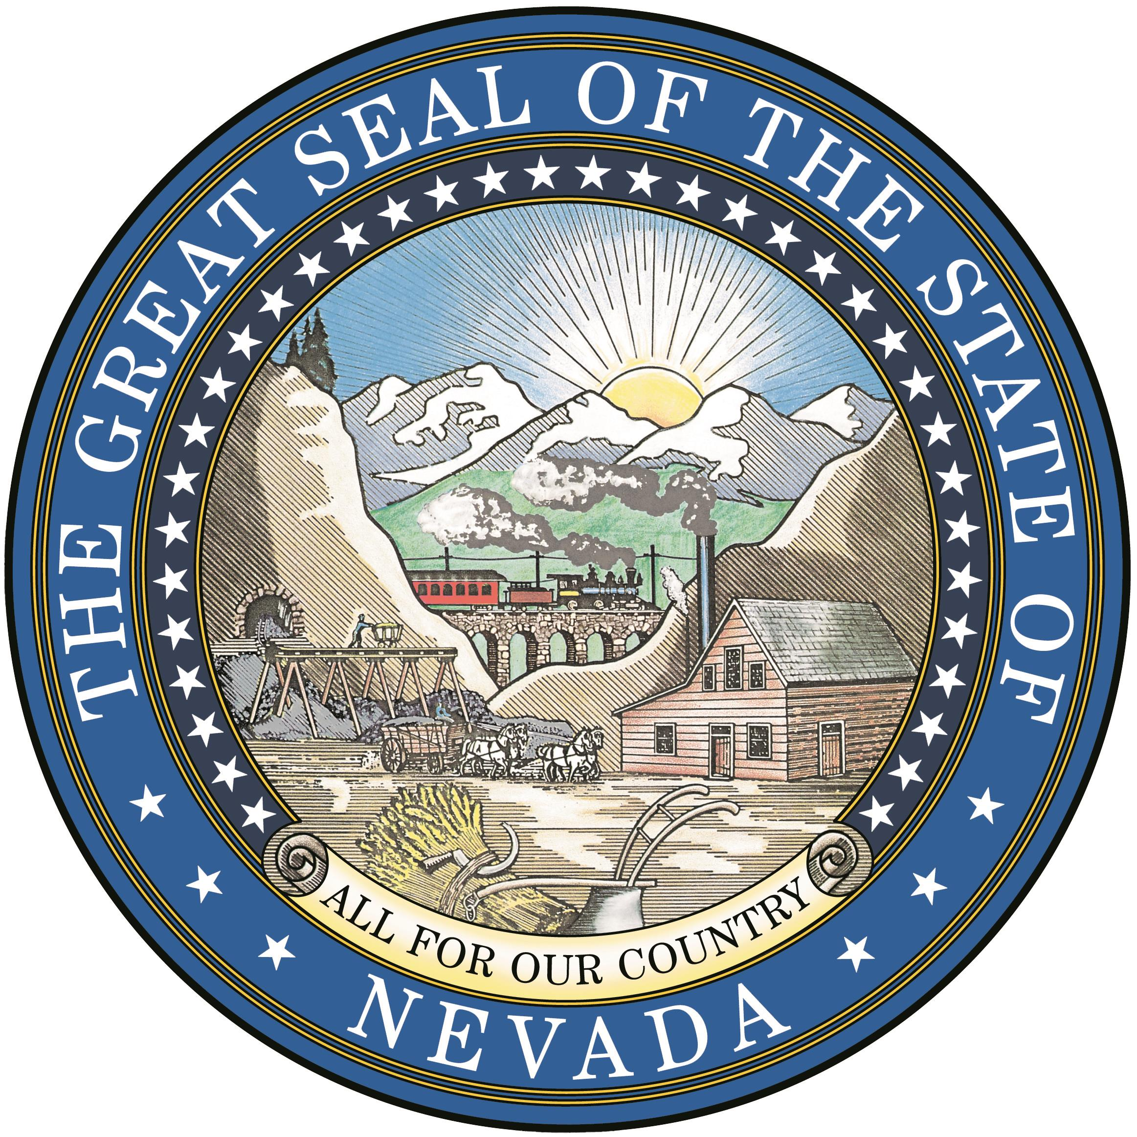
JANE GRUNER
Administrator

Senior Tax Assistance Rebate Program

Requirements and Instructions, 2016 Applications

- AGE: Claimant must be 65 years of age, on or before, June 30, 2015.
- INCOME: includes 2015 income from all sources, both claimant and spouse. Maximum income per 2015 individual $23,540.00, claimant and spouse maximum income $31,860.
- RESIDENCY: Must have lived and paid property taxes, continuously, in Nevada, from at least July 1, 2015, and must be a full-time Nevada resident at the time of application.
- Residence assessed greater than $500,000 will require a credit report of the Claimant and Spouse.
- Claimant or Spouse cannot own, or their names appear on, any property other than their primary residence. This includes property anywhere.
- Claimant and/or Spouse cannot have “Liquid Assets” in excess of $150,000. Liquid assets can be: checking or savings accounts, IRAs, CDs, stocks & bonds, annuities, etc.
- Application must be filed with the State of Nevada Aging and Disability Services Division by September 30, 2016.

THE FOLLOWING INFORMATION MUST BE ATTACHED TO THE APPLICATION

- The claimant and spouse (if applicable) must provide proof of date of birth. Attach a copy of one of the following for each: Nevada Driver’s License or Nevada ID card; Birth Certificate; a statement from Social Security (telephone 1-800-772-1213) TTY 1-800-325-0778 that shows “according to their records, your birth date is …..”
- The claimant and spouse (if applicable) must provide proof of Social Security Numbers.
- Submit copies of all 2015 year-end income statements. Income includes, but is not limited to Social Security (to request a duplicate copy of 2015 Benefits Verification Letter call Social Security at 1-800-772-1213); VA (to request a benefit statement from VA for 2015 income call 1-800-827-1000) or TTY 1-800-325-0778; pensions; annuities; IRAs; interest and/or dividends (including non-taxable amounts); capital gains/(loss) (which includes gain from sale of home, even if excluded from federal income taxes); Income from foreign countries; gaming; business income; wages; unemployment; disability income (from any source); net rent received; royalties; estates; inheritances; gifts; family/friend support; babysitting; business and services in exchange for living expense or “rent”.
- If claimant receives railroad pension, a copy of the form for 2015 must be attached.
- If claimant receives income from a foreign country, and does not receive a 1099, a copy of the conversion into U.S. funds for each payment received during the 2015 year must be submitted.
- W-2 forms for wages and 1099 form for any unemployment, capital gain/loss, interest/dividends, pension, IRAs, annuities, etc. must be submitted.
- If interest and/or dividends total $2,500 or more, documentation to show the total dollar amount in each of these accounts as of December 31, 2015 must be submitted.
- You must complete both sides of the application, attach required documentations, sign & date and return original form to:
Aging and Disability Services Division – STAR Program
3416 Goni Rd, Bldg D #132
Carson City, NV 89706

DEADLINE FOR FILING — September 30, 2016

