State of Nevada
Department of Business & Industry
HOUSING DIVISION
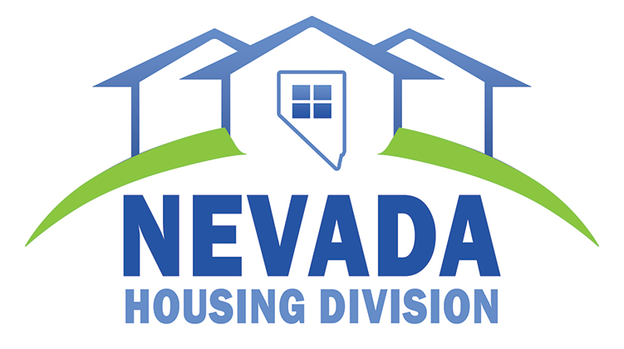
1830 College Parkway, Ste. 200
Carson City, Nevada 89706
Tel.: (775) 687-2240 or (800) 227-4960
Fax: (775) 687-4040
e-mail: mwelden@housing.nv.gov

NEVADA HOUSING DIVISION
MOVE-IN/MOVE-OUT REPORT

PROJECT OWNER: PROJECT NAME: DATE

ANY CHANGES FROM THE PREVIOUS REPORT REGARDING THE STATUS OF HOME AND TRUST FUND UNITS MUST BE LISTED HERE
DELETIONS |  |  | ADDITIONS
UNIT # | TENANT | MOVE-OUT DATE | UNIT # | TENANT | MOVE-IN DATE

DELETIONS |  |  | ADDITIONS
UNIT # | TENANT | MOVE-OUT DATE | UNIT # | TENANT

