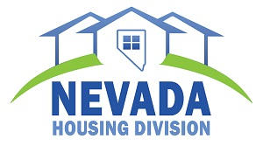

The State of Nevada Housing Division in Association with the Clark County
School-Community Partnership Program proudly invites you and your family to the

2015 “Where I Live”
Artist Reception and Award Presentation

Thursday, December 17, 2015
Delfino Ballroom
The Venetian – Las Vegas

Exhibit Viewing
5:00 p.m. – 8:00 p.m.
Reception
6:00 p.m.
Award Program
6:30 p.m.

